Program Charter  
e-Parliament – Phase 1

Approval

|  |  |  |  |
| --- | --- | --- | --- |
| **Name** | **Role Business (MOA) Program Team (MOE)** | **Approval Y/N** | **Date Approval** |
| PGB Permanent Members | Program Governance Board (MOA) |  |  |

CIRCULATION

|  |  |  |  |
| --- | --- | --- | --- |
| **Name -Telephone number** | | **DG or Company** | **ERICA[1] code** |
| PGB Permanent Members - refer to 6.1.6 |  |  | A |
| PGB Information Providers - refer to 6.1.6 |  |  | I |
| Program Steering Committee Members - refer to 6.1.6 |  | ITEC | I, C |
| LEBOEUF Olivier |  | ITEC | I, C |
| ALARI Gianluigi |  | ITEC | R |
|  |  |  |  |

Updates

|  |  |  |  |  |
| --- | --- | --- | --- | --- |
| **Version** | **Date** | **Sections changed** | **Description** | **Author(s)** |
| 1.0 | 16/11/2012 |  | Initial version | ALARI G.  LEBOEUF O.  CHALAUX F. |
| 2.0 | 19/11/2013 | Various | Version aligned to phase 1 (scope, approach & roadmap) | CHALAUX F.  ALARI G. |
|  |  |  |  |  |

Table OF CONTENTs

1. General introduction 5

1.1. Purpose 5

1.2. Usage conventions 5

1.3. Applicable and Reference Documents 5

1.3.1. Applicable Documents 5

1.3.2. Reference Documents 5

1.4. Glossary 6

1.5. Methodological aspects 6

1.5.1. PPO4EP 6

1.5.2. PMM4EP 6

1.5.3. BPMM4EP 6

1.5.4. Change and Risk Management 6

1.5.5. Obligation to inform the Data Protection Officer 7

2. e-parliament Program 8

2.1. Program overview 8

2.2. Business objectives 8

3. Scope and Architecture 10

3.1. Functional scope 10

3.2. Architecture 13

3.2.1. AT4AM - Authoring Tool for AMendments 14

3.2.2. AT4LEX - Authoring Tool for parliamentary texts 14

3.2.3. DST - Drafting Support Tool 14

3.2.4. CAT4TRAD - Computer-aided translation tool 14

3.2.5. XML4EP - XML for EP contents 14

3.2.6. DM-XML - XML Document Management 15

3.2.7. PURE-XML - Parliament Unique REpository for XML text 15

3.2.8. DiSP - Digital Signature 15

3.2.9. EPS - e-Parliament Services 15

4. Program Deliverables and milestones 16

4.1. Definition of a delivery in the context of e-Parliament 16

4.2. Pilot text production chain: Reports & Amendments 16

4.3. High level roadmap 17

4.4. Program includes 18

4.5. Program excludes 18

5. Risks, Success Factors, Constraints and Assumptions 19

5.1. Risks 19

5.2. Success factors 19

5.3. Constraints 20

5.4. Assumptions 20

6. Organisation - Key Roles and responsibilities 21

6.1. Program Team 21

6.1.1. Program Sponsor 21

6.1.2. Program Manager 21

6.1.3. Program Business Analyst 21

6.1.4. Program Functional Architect 22

6.1.5. Program Technical Architect 22

6.1.6. Program Steering Committees 23

6.2. Key stakeholders 24

7. Program Charter - Approval 25

# General introduction

## Purpose

The purpose of the **Program Charter** is to describe in more detail the program e‑Parliament in terms of scope and architecture, delivery and roadmap. The document *Program Mandate* has been used as a basis for developing the Program Charter.

In order to standardise the structure and facilitate the integration of PPO4EP, this document is based on a PPO4EP template for which this chapter explains the common usage.

## Usage conventions

The parts in yellow indicate the area where information should be entered, and must remain in yellow to highlight information connected with the program.

Where a chapter or section is not considered to be applicable, put ‘**NOT APPLICABLE**’.

If the information for a chapter or section is not yet available, it must be stated when, how and where this information will be available.

**Click on the Show/Hide  button in the toolbar to display/hide guidance on filling in this document.**

Guidance displayed.

## Applicable and Reference Documents

This chapter sets out the reference documents on which this guide is based.

### Applicable Documents

This section details the applicable documents used in drafting this document. The applicable documents are standards, specimen plans which need to be applied and whose application is verifiable.

| **N°** | **Title** | **Remarks** |
| --- | --- | --- |
| [1] | PPO4EP version 1.0 | Published on the ISMsnet site 15 June 2010 |
| [2] | Program Management Life Cycle definition | Reference PPO4EP_Presentation_PM_EN_v11 |
| [3] | Technical Consolidation of IRO Information Models | Reference Final Consolidation Ultimate IRO model  Published on IRO website, October 2008  http://eicisdw.ep.parl.union.eu/sdw/iro/index.cfm |

### Reference Documents

This section details the reference documents used in drafting this document. Reference documents help in defining the program but are not directly applicable (e.g. software reference manuals, sample files from outside firms, meeting papers).

| **N°** | **Title** | **Remarks** |
| --- | --- | --- |
| [1] | Program Mandate | Document approved by Program Steering Committee members (October 26th, 2011)  Reference EPARL_MANDA_20110509_EN_V11 |
|  |  |  |

## Glossary

The glossary is available at [**ISMSnet**](http://www.ismsnet.ep.parl.union.eu/ispnet/cms/cache/offonce/preconisations/P_Methodologie): - Zone 'Vos indispensables' - Glossaire.

| **Abbreviation** | **Description** |
| --- | --- |
| Akoma Ntoso | XML for parliamentary, legislative & judiciary documents- http://www.akomantoso.org/ |
| PPBS | Program Product Breakdown Structure |
| IRO | Information Resource Officer |

## Methodological aspects

### PPO4EP

The Program Management Methodology used at the European parliament is **PPO4EP.**

For more information see [ISMSnet](http://www.ismsnet.ep.parl.union.eu/ispnet/cms/preconisations/P_Methodologie).

### PMM4EP

The Project Management Methodology used at the European parliament is **PMM4EP.**

For more information see [ISMSnet](http://www.ismsnet.ep.parl.union.eu/ispnet/cms/preconisations/P_Methodologie).

### BPMM4EP

The Business Process Management Methodology used at the European parliament is **BPMM4EP.**

For more information see [ISMSnet](http://www.ismsnet.ep.parl.union.eu/ispnet/cms/preconisations/P_Methodologie).

### Change and Risk Management

The Change and Risk management strategy will be supported by the Program Manager according to the preconisation in place. The 'Program Management Plan' has to describe in details the way of managing those aspects.

### Obligation to inform the Data Protection Officer

The Article 25 of Regulation (EC) N°45/2001 provides that "The controller shall give prior notice to the Data Protection Officer of any processing operation or set of such operations intended to serve a single purpose or several related purposes".

For each project, the Project Manager has to inform the Data Protection Officer as described in the PMM4EP template: **'Project Charter'**.

# e-parliament Program

## Program overview

The program is described in a high level in the 'Program Mandate' document. If more information is known, please describe only the new known information.

The high level program vision, objectives and needs are described in chapter 2 of the Program Mandate (no additional information identified).

e‑Parliament is designed as a major multi-annual change program aimed at modernising the EP's core parliamentary information system. To control the changes and risks introduced by the program, e-Parliament progressively achieves its objectives by implementing the following two phases:

1. Phase 1 is focused on parliamentary text management and may introduce changes in related processes (Business/IT alignment). It deals with the nature of the product (text) and its control in terms of life cycle and versioning.
2. Phase 2 will be activity/process oriented and information provision. It deals with the optimization of text production processes and the workflows that support them. This phase is not described in this document.

Each phase is divided into two steps:

* Setup of foundation elements and first use; this step is managed under program framework PPO4EP version 1.0.
* Alignment of all relevant existing applications to foundation elements; this step will be managed as IT projects portfolio management. The alignments are out of the scope of e-Parliament program.

This Program Charter addresses the first phase and first step of e-Parliament vision, namely the setup of the foundation elements and their first use in the context of the parliamentary text management.

## Business objectives

Relative to the 'Program Mandate' document, the business objectives could be more detailed because more information is known.

If it is the case, please describe the business objectives in details (SMART), if not, please mention N/A.

To describe your objective, you can use a template described in the **chapter** Error! Reference source not found..

DG Innovation and Technological Support is proposing to revamp existing information circuits by developing a new integrated architecture. The business objectives are derived from the *Administrative Work Programme*[2]:

* Business objective 1: facilitate document creation.
* Business objective 2: facilitate document verification.
* Business objective 3: minimise input errors.
* Business objective 4: make texts easier to reuse for translation.
* Business objective 5: make texts easier to reuse for publication on paper.
* Business objective 6: make texts easier to reuse for electronic dissemination Internet.
* Business objective 7: make texts easier to reuse for electronic dissemination Intranet.
* Business objective 8: improve the quality of texts produced.
* Business objective 9: reduce costs over the life-cycle of documents.
* Business objective 10: provide electronic signature.

# Scope and Architecture

## Functional scope

The functional scope of this phase is divided into text production chains. A chain is a set of processes, actors and tools across a range of DGs linked together to produce a collection of texts, the current identified text production chains are:

* Reports & Amendments.
* Committees Agenda.
* Plenary Verbatim.
* Parliamentary Questions.
* Written Declarations.
* Plenary Minutes.
* Committees Minutes.
* Plenary Agenda.

The first phase of the program deals with the definition of the e-Parliament architecture for the parliamentary text management: the foundation elements will be created by progressively building new components and adapting legacy applications to the new XML-based architecture.

The figure below illustrates the approach chosen to transform the EP’s core information system.

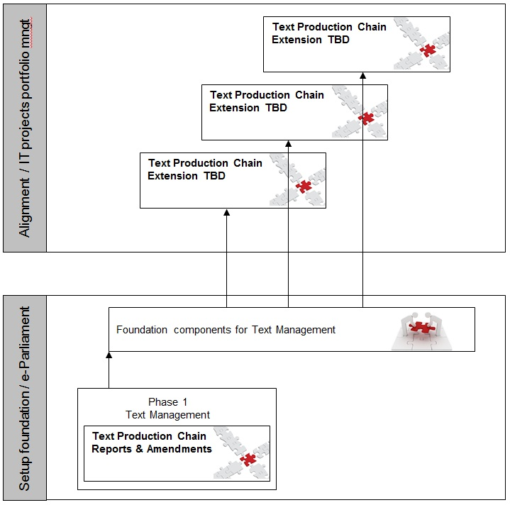

Figure 1 – Scope management approach

For this phase, the program treats the Reports & Amendments production chain as a pilot on which the foundation components of the e-Parliament architecture will be built.

Once the foundation components are operational for the pilot chain, further text production chains will be aligned to the e-Parliament architecture after completion of the first phase of the program.

The alignment of the chains to the e-Parliament architecture is out of scope of the program as such. The application e-Parliament principles and foundations to other text production chains or information systems are considered as an extension of e-Parliament. The knowledge gained and principles developed by the program in terms of technical foundations, business logic and program organisation, during phase 1 of the program will be made available to further parliamentary text production chains for which maintenance activities and/or new projects will be launched.

The text production management has been divided into nine functional areas as summarised below:

1. XMLisation: the transformation of MS Word content into an XML format suitable for processing with e-Parliament tools.
2. Digital Signature: the use of digital signatures as an alternative to manual signatures where the Parliamentary rules prescribe that a text must be signed by Members of Parliament (e.g. legislative amendments, written declaration, etc.) on internal EP documents.
3. Drafting: creation of parliamentary (legislative and non-legislative) texts in XML Akoma Ntoso format.
4. Verification: collaboration on drafting amendments and linguistic verification of documents that were produced using an e-Parliament authoring tool.
5. Internal Translation: translation of XML Akoma Ntoso content by DG TRAD staff.
6. External Translation: the possibility to outsource the translation of XML Akoma Ntoso content assuming that the translated content respects the Akoma Ntoso format.
7. Consolidated Texts: the possibility to produce XML Akoma Ntoso text amending a base text in the context of a 1st reading agreement. The amendments are directly consolidated in these texts ("pre-adoption finalisation" and "consolidated amendment" documents).
8. Consolidated Texts (TC):   
   a. Consolidation of Final Reports, on the basis of the Draft Report, Opinions and voted amendments adopted in Committee.

b. Production of the Consolidated Text (TC), on the basis of the Adopted Act Text and the Commission's legislative proposal.

1. Adopted Texts (TA): production with e-Parliament tools and in XML Akoma Ntoso format of the Parliament's Adopted Text (TA).

## Architecture

Phase 1 of the program will create specific business components (AT4AM), re-usable business components (AT4LEX, DST, CAT4TRAD) as well as technical support services (XML4EP, DM-XML, PURE-XML, DiSP, EPS).

The goals in terms of the management of parliamentary texts are to introduce in particular:

* Apply the XML Akoma Ntoso standard to parliamentary texts (foundations XML4EP and DM-XML).
* Use a single central repository for content created during the entire lifecycle of the parliamentary text production chain (PURE-XML).
* Allow parliamentary texts to be signed digitally.
* Create reusable components and services that can be used for further applications (centralisation of processes in DM-XML, PURE-XML, DiSP, EPS).

The figure below summarises the architecture of the foundation components of the phase 1 and how they apply to document processes.

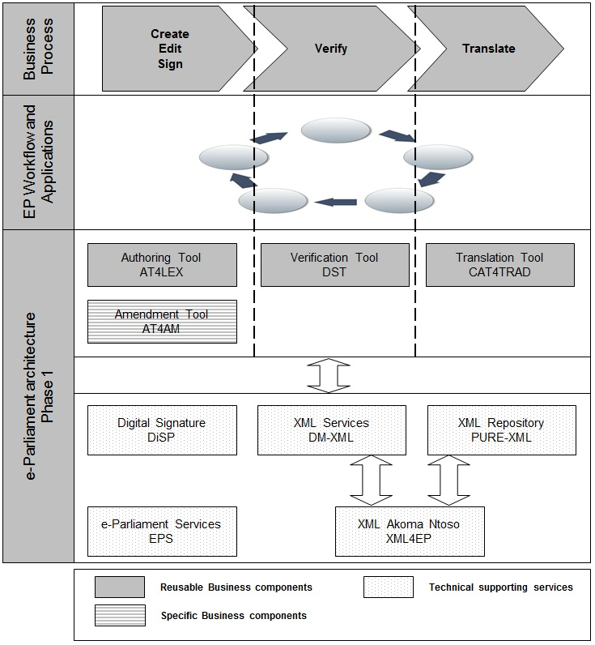

Figure 2 – Program architecture

Each component will produce a range of deliverables that are further detailed below.

Describe each component in a sufficient detail to be comprehensive.

### AT4AM - Authoring Tool for AMendments

Describe each component in a sufficient detail to be comprehensive.

AT4AM is the e-Parliament specific business component covering the authoring of amendments on parliamentary texts (legislative and non-legislative procedures) and the production of amendment's lists for downstream services.

This application relies on the e-Parliament technical supporting services.

### AT4LEX - Authoring Tool for parliamentary texts

AT4LEX is the e-Parliament reusable business component covering the authoring of parliamentary texts (legislative and non-legislative procedures). Supporting content assembly and re-use, this business component will enable MEPs and EP officials to focus on content rather than on document layout, and will also make documents downstream treatments more efficient.

This application relies on the e-Parliament technical supporting services.

### DST - Drafting Support Tool

DST is the e-Parliament reusable business component covering the verification of parliamentary texts (legislative and non-legislative procedures) produced by authoring tools aligned to the e‑Parliament architecture. This component supports the collaboration between authors and lawyer linguists on drafting amendments.

This application relies on the e-Parliament technical supporting services.

### CAT4TRAD - Computer-aided translation tool

Describe each component in a sufficient detail to be comprehensive.

CAT4TRAD[3] is the e-Parliament reusable business component covering the translation of parliamentary texts (legislative and non-legislative procedures) produced by authoring tools aligned to the e‑Parliament architecture.

This application relies on the e-Parliament technical supporting services.

### XML4EP - XML for EP contents

XML4EP is the e-Parliament activity aiming to select an XML standard (Akoma Ntoso) for EP parliamentary texts, to specify accordingly the XML representation of EP content, to provide support to the delivery teams for content and document representation and to identify management needs for the XML content representation.

### DM-XML - XML Document Management

DM-XML is the e-Parliament technical supporting service providing a unique services layer for XML text handling to the applications compliant to the e‑Parliament architecture.

### PURE-XML - Parliament Unique REpository for XML text

PURE-XML is the e-Parliament technical supporting service providing a unique content repository to the applications compliant to the e-Parliament architecture and the IRO models.

### DiSP - Digital Signature

DiSP is the e-Parliament technical supporting service providing a portal to manage the digital signature in different documents.

### EPS - e-Parliament Services

EPS is the e-Parliament technical supporting service providing common services and libraries for the e-Parliament reusable business components and the applications integrated with the e-Parliament architecture.

# Program Deliverables and milestones

## Definition of a delivery in the context of e-Parliament

A delivery is the organisational and technical change of a text production chain impacting processes, services and information systems.

On an operational level, a delivery is the entire range of means (technologies, methods, tools, courses of action) that are used to put into production the foundation components and other non-program components foreseen in the e-Parliament core architecture.

The incremental approach of e-Parliament is to gradually align text production chains to the program architecture through successive deliveries.

## Pilot text production chain: Reports & Amendments

List the major deliverables that relate to this program.

The Reports & Amendments text production chain consists of processes that are supported by all nine functional areas described in section 3.1 and for this reason it has been selected to be the first text production chain to be implemented by the program. This decision allows us to gradually put in place all key e-Parliament components as defined in the previous chapter. The following table lists the deliveries identified to cover the functional scope and deliver the technical architecture and its components (i.e. section 3.2).

|  |  |  |  |  |  |  |  |  |  |
| --- | --- | --- | --- | --- | --- | --- | --- | --- | --- |
| **XML-**  **isation** | **Digit.**  **Sign.** | **Drafting** | **Verifica-tion** | **Internal**  **Trans.** | **External**  **Trans.** | **Consol.**  **Texts** | **Consol.**  **Texts (TC)** | **Adopted**  **Texts**  **(TA)** | **Functional areas / Deliveries** |
| **√** |  | **√**  Amend-ment | **√**  Amend-  ment |  |  |  |  |  | **Amendments** |
|  |  |  |  | **√**  OJ |  |  |  |  | **XML-IT** |
|  | **√**  Amend-ment |  |  |  |  |  |  |  | **DiSP4AM** |
|  |  | **√**  AM doc. | **√**  AM doc. | **√**  Amendment  AM doc. |  |  |  |  | **AM-Batch** |
|  |  | **√**  Report  Opinion | **√**  Report  Opinion | **√**  Report  Opinion |  |  | **√**  Final INI/INL Report | **√**  Final INI/INL Report | **Reports** |
|  |  |  |  |  | **√** |  |  |  | **Transl.**  **outsourcing** |
|  |  |  |  |  |  | **√** |  |  | **1st Read. agreement** |
|  |  |  |  |  |  |  | **√**  TC | **√**  TA | **TA/TC** |

From this table we see that the Reports & Amendments text production chain scope has been phased into seven core deliveries:

1. Amendments (drafting of amendments).
2. DiSP4AM (signing of amendments).
3. AM-Batch (management and translation of AM documents).
4. Reports (drafting, verification and internal translation of Reports and Opinions including some support to consolidation).
5. Translation outsourcing (extension to support translation outsourcing).
6. 1st reading agreement (support to consolidated texts following an EP and Council agreement).
7. TA/TC (extended support to text consolidation and adoption).

The XML-IT delivery partially supports the Committee agenda text production chain but has been instrumental for the early introduction of the Cat4Trad component supporting the internal translation functionality.

## High level roadmap

The following table lists key milestones to deliver all key e-Parliament components and unlock the realisation of the benefits of the program by offering an integrated architecture to handle structured text.

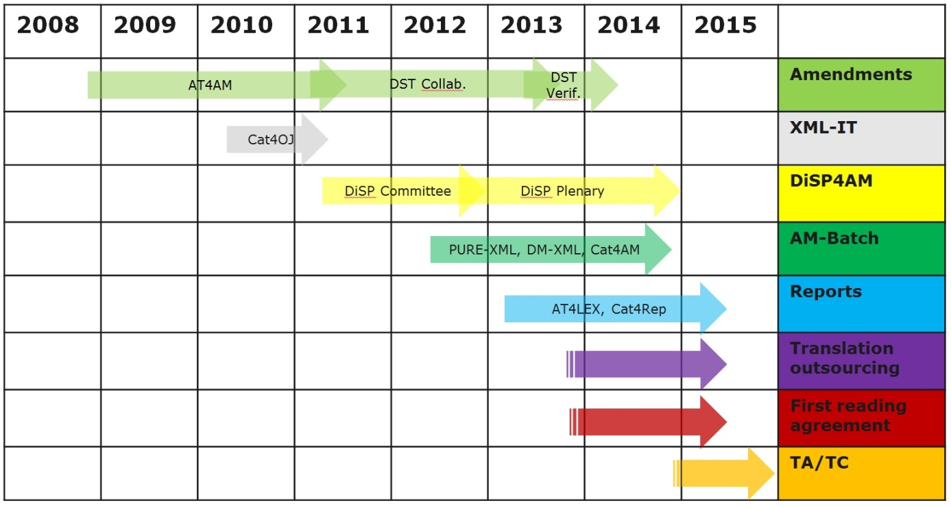

## Program includes

Describe the included components (project, activities, etc.).

|  |  |
| --- | --- |
| **Items** | **Description/Comment** |
| Scope | This Program Charter deals with the first phase and first step of e-Parliament vision, including the delivery of:   * Foundation components described in section 3.2 (reusable business components, specific business component and technical supporting services). * Seven core deliveries described in section 4.2 and XML-IT delivery. |
| XMLisation | Legislative proposals from the European Commission must be converted from RTF/DOC to XML format. |
|  |  |

## Program excludes

Describe the excluded components (project, activities, etc.).

|  |  |
| --- | --- |
| **Items** | **Description/Comment** |
| Scope | This Program Charter does not cover the alignment of all relevant existing applications. |
| Components | Maintenance of components is excluded from the program. |
| Dissemination | Dissemination systems are not studied in e-Parliament. Benefits are indirectly delivered to dissemination systems through the delivery of XML text contents. |
|  |  |

# Risks, Success Factors, Constraints and Assumptions

## Risks

The information given in this section must be fleshed out in the 'Program Dashboard' - 'Risks' sheet.

As of today (16/11/2012), the highest risks for the program are listed below:

* Wrong estimations of budget and planning.
* Program scope creep.
* Conflicts between long-term e-Parliament objectives and short-term expectations of clients internal and/or external to the program.
* Insufficient cooperation/communication between Units/Services.
* Complex interdependencies between projects within the program and outside the program.
* Instability of project teams as a result of the transition to EP framework contracts.
* Resistance to change.
* Difficulty to establish business benefits measurement models and estimations.
* Lack of experience and feedback for outsourced development.
* Impact of administrative processes on planning.

## Success factors

This section can be used to list factors that can facilitate successful completion of the program.

Some key success factors have been identified during the previous phases (cf. Program Mandate - section Assumptions), some are new (*italic*):

* Strong support from client DGs Management.
* Strong sponsorship and support from DG ITEC/DIT Management.
* Sufficient human and financial resources.
* Alignment between long-term e-Parliament objectives and expectations of clients internal and/or external to the program.
* Collaboration inside and outside DIT.
* *Effective delivery culture and transversal organisation (vs. "single project" culture).*
* *Active involvement of DGs, MEPs and users.*
* *Support from the stakeholders for induced changes in working procedures.*
* *Highly skilled and trained staff.*

## Constraints

Constraints are restrictions or limitations, both within and outside the program, with an influence on the conduct of the program. This section sets out the program-specific constraints inherent in the way the requester works (performance, security, timetable, budget, ergonomics, etc.).

Program constraints are listed in the Program Mandate (no additional information identified).

## Assumptions

This section lists any assumption identified.

Program assumptions are listed in the Program Mandate (no additional information identified).

# Organisation - Key Roles and responsibilities

The key roles listed below are defined in PPO4EP framework:

* Program Executive Sponsor.
* Program Manager.
* Program ICT Architect.
* Program Business Analysts.
* Program Steering Committee (Program Board).
* Program Management Board (Strategic Governing Board).
* Project Manager.

These responsibilities have been refined in e-Parliament, especially for program delivery management (described in Program Management Plan):

* Program Functional Architect.
* Program Technical Architect.

## Program Team

By answering the following questions, the overall roles and responsibilities for a program can be identiﬁed and described:

* What is the composition of the Program Steering Committee? What is the frequency of meetings? How are issues escalated to the board? How does the board communicate its decisions?
* What is the role and responsibility of the Program Sponsor and constituent sponsors?
* What are the roles and responsibilities of the Program Manager and constituent component owners?
* What is the role of the Program Support Office?
* Who will be accountable for delivery?
* Who will ensure that benefits are realized and the value is delivered?
* Who will ensure that architectural principles are not violated?
* Who will provide administrative, guidance, consulting, and oversight service to the program and constituent components?
* Who will ensure appropriate, effective, efficient, and timely communication with all stakeholder groups and specific stakeholders?

### Program Sponsor

The **Program Sponsor** (MOA) is the individual or group who champions the program initiative.

|  |  |
| --- | --- |
| Program Sponsor | VILELLA Giancarlo |
| DG/Unit/Service | ITEC |

### Program Manager

The **Program Manager** is responsible for day-to-day management of the program, its activities and staff.

|  |  |
| --- | --- |
| Program Manager | ALARI Gianluigi |
| DG/Unit/Service | ITEC/DIT/ICTCD/CDPM |

### Program Business Analyst

The **Business Analyst** is responsible for the definition and maintenance of the in-scope organisation, business processes and information services of the organisation(s) sponsoring the program and beyond.

|  |  |
| --- | --- |
| **Business Analyst** | BACKAERT Guy |
| DG/Unit/Service | PRES/Directorate for Resources/IT and internal Communication Unit |
| **Business Analyst** | WEBER AMOREAU Maite |
| DG/Unit/Service | TRAD/Directorate for Support and Technological Services for Translation |
| **Business Analyst** | BASTIANETTO Veronica |
| DG/Unit/Service | IPOL/Directorate for Resources/Informatics Unit |
| **Business Analyst** | MARTINS Fernanda |
| DG/Unit/Service | IPOL/Directorate for Resources/Informatics Unit |
| **Business Analyst** | WILSON Tim |
| DG/Unit/Service | EXPO/Directorate for Resources/Finance Unit |

### Program Functional Architect

|  |  |
| --- | --- |
| Program Functional Architect | ALARI Gianluigi |
| DG/Unit/Service | ITEC/DIT/ICTCD/CDPM |

### Program Technical Architect

|  |  |
| --- | --- |
| Program Technical Architect | CERRO GINES Jesus |
| DG/Unit/Service | ITEC/DIT/ICTCD/CDPM |

### Program Steering Committees

What is the recommended governance structure to manage, control, and support the program? What are the recommended governance structures to manage and control projects and other program components, including reporting requirements?

| **Governance Structures** | **Role/function** | **Name** | **DG** |
| --- | --- | --- | --- |
| **Program Governance Board** | The PGB is empowered to make decision regarding program scope, schedules, changes, benefits, communication and to lead the program alignment with the program business side Directorate General's strategic AWP.  PGB members are thus empowered to steer business process changes and to escalate to the ICT Steering Committee for EP-strategic decisions. | | |
| Permanent Members | | | |
|  | Director RESOURCES | DE VICENTE Raquel | IPOL |
| Director RESOURCES | BERTON Jean-Louis | EXPO |
| Director PLENARY  Director LEGISLATIVE ACTS  Director RESOURCES | DUNSTAN Paul  KNUDSEN Kristian  CAROZZA Elio | PRES |
| Director SUPPORT/TECHNO  Director TRANSLATION | VAN HOOF Han  MAVRIC Valter | TRAD |
| Head of Department  Program Manager | LEBOEUF Olivier  ALARI Gianluigi | ITEC |
| Information Providers | | | |
|  | Business Analyst | BASTIANETTO Veronica | IPOL |
| Business Analyst | MARTINS Fernanda | IPOL |
| Business Analyst | WILSON Tim | EXPO |
| Business Analyst | BACKAERT Guy | PRES |
| Head of Unit Legislative Quality | ROBSON Ellen | PRES |
| Head of Unit Tabling Desk | WICKER Steven | PRES |
| File manager | POLJANCIC Lea | EXPO |
| Head of Unit IT and internal Communication | DIAS FERNANDES Victor | PRES |
| Business Analyst | WEBER AMOREAU Maite | TRAD |
| Program Technical Architect  Program Support Office | CERRO GINES Jesus  CHALAUX Franck | ITEC |
| **Program Steering Committee** | The e-Parliament Program Steering Committee is empowered to make decision regarding program budget and to lead the program alignment to DG ITEC strategic AWP | | |
|  | Director General of DG ITEC  Program Sponsor | VILELLA Giancarlo | ITEC |
| Information Technologies Director | EILERTSEN Steen | ITEC |
| ICTAS Head of Unit | PARIDANS Pascal | ITEC |
| ICTCD Head of Unit  Project Management Office | DELEPINE Ludovic | ITEC |
| Head of Department | LEBOEUF Olivier | ITEC |
| Program Manager | ALARI Gianluigi | ITEC |

## Key stakeholders

|  |  |  |
| --- | --- | --- |
| **Role** | **Name** | **DG** |
| Highest decision-maker of DG PRES | RATTI Francesca | Deputy Secretary General  Director General PRES |
| Highest decision-maker of DG IPOL | RIBERA D'ALCALA Riccardo | Director General IPOL |
| Highest decision-maker of DG EXPO | AGUIRIANO NALDA Luis Marco | Director General EXPO |
| Highest decision-maker of DG TRAD | PITT Janet | Director General TRAD |

# Program Charter - Approval

|  |  |  |  |  |
| --- | --- | --- | --- | --- |
| **Program Name** | | **e-Parliament** | | |
| *We, hereunder, have reviewed the information contained in this document and agree.* | | | | |
| **Name** | **Role** | | **Approval**  **Y/N** | **Date (mm/dd/yyyy)** |
| PGB Permanent Members | Program Governance Board | |  |  |

*By signing this document, they agree to this as the formal* ***'Program Charter'****.*

1. **E**: Examination, **R**: Responsible, **I**: Information, **C**: Contribution, **A**: Approval
2. Program Mandate, p. 6-7.
3. This component is managed under the e-Parliament program framework, the budget is managed by DG TRAD and the MOE of the project is DG TRAD